|  |  |  |  |  |
| --- | --- | --- | --- | --- |
|  | 2010 season | 2011 season | 2010_coh_int | 2010_coh_int |
| Mean | -125 | -130 | -142 | -147 |
| Median | -125 | -130 | -143 | -147 |

Peterman Bed Power DataSet Statistics

|  |  |  |  |
| --- | --- | --- | --- |
|  | Combineddata | Crossline | Verticalline |
| Mean | -128.7148 | -129 | -127 |
| Median | -129.0650 | -129 | -128 |

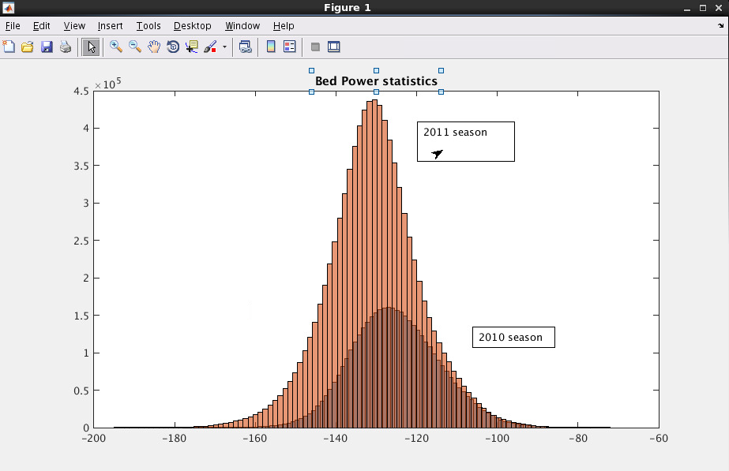

Ice Bed Power Statistics after Geometric Correction

|  |  |  |  |  |
| --- | --- | --- | --- | --- |
|  | 2010 season | 2011 season | 2010_coh_int | 2010_coh_int |
| Mean | -125 | -130 | -142 | -147 |
| Median | -125 | -130 | -143 | -147 |

|  |  |  |  |  |  |  |  |  |
| --- | --- | --- | --- | --- | --- | --- | --- | --- |
|  | Combineddata (ref Median) | Combined datacohint | vertical | crossline | Data_2010 | Data_2011 | Data_2011  _coh_int | Data_2010_  coh_int |
| Mean | -43.1831 | -65 | -59.8766 | -60.3654 | -42 | -45 | -63 | -62 |
| Median | -55.6966 | -84 | -31.6 | -46.8923 | -53 | -56.6 | -78 | -75 |
| Max Power | -8.37 | -35 | 2.6 | -13.2162 | -10.17 | -8.37 | -28 | -36 |
| Min Power | -95 | -142 | -97 | -125 | -75 | -95 | -142 | -128 |
| Dynamic Range | 86 | 114 | 100 | 112 | 65 | 86 | 114 | 92 |
| Mean Depth | 1.5562(1.477 all) | 2.1093 | 1.4194 | 1.5838 | 1.334 | 1.6643 | 1.6562 | 1.3291 |
| Na_regress | 8.2307 | 6.8 | 9.0 | 8.6875 | 9.65 | 9.3087 | 8.3694 | 9.67 |
| Na_bar | 8.25 (10.1 all) | 6.8 | 9.1 | 8.7 | 9.65 | 9.3 | 8.35 | 9.7 |

Jacobshavn Data Statistics

|  |  |  |  |  |  |
| --- | --- | --- | --- | --- | --- |
|  | 2010 | 2011 | 2012 | 2013 | 2014 |
| Mean | -121.9 | -125.9691 | -124 | -134 | -132 |
| Median | -121 | -125 | -123 | -133 | -131 |

|  |  |  |  |
| --- | --- | --- | --- |
|  | Combineddata | Crossline | Verticalline |
| Mean | -128.6964 | -128.662 | -128.7163 |
| Median | -128.0014 | -128.5776 | -127.6904 |

|  |  |  |  |  |  |  |  |  |  |
| --- | --- | --- | --- | --- | --- | --- | --- | --- | --- |
|  | Combineddata | vertical | crossline | Data_2008 | Data_2010 | Data_2011 | Data_2012 | Data_2013 | Data 2014 |
| Median | -62.625 | -61 | -62.6 | -64 | -53 | -64 | -58 | -63 | -58 |
| Mean | -41.99 | -46.6 | -43.44 | -41 | -40 | -46 | -38 | -52 | -46 |
| Max Power | -0.98 | -13.6709 | -10.33 | -0.98 | -13.8 | -18 | -5 | -25 | -16 |
| Min Power | -98 | -127.834 | -127 | -97 | -91.5 | -95 | -92 | -88 | -98 |
| Dynamic Range | 97 | 114 | 113.4 | 96 | 77.64 | 77 | 87 | 63 | 81 |
| Mean Depth | 1.1571 | 1.1544 | 1.6595 | 1.8517 | 1.1353 | 1.5675 | 1.468 | 1.0798 | 1.2328 |
| Na_regress | 7.3452 | 12.9854 | 6.7511 | 7.2732 | 12.7266 | 11.3346 | 11.4567 | 9.86 | 12.782 |
| Na_bar | 7.35 | 13 | 6.75 | 7.25 | 12.75 | 11.35 | 11.45 | 9.85 | 12.8 |

Peterman std data

|  |  |  |
| --- | --- | --- |
| 2010  median_power =  -490.7141  mean_power =  -442.8374  max_power =  -401.3361  min_power =  -546.1020  dynamic_range =  144.7659  avg_depth =  1.3366e+03  Na_reg =  22.4496  Na_bar =  22.2000 | 2011  median_power =  -117.6878  mean_power =  -46.2600  max_power =  1.5754  min_power =  -185.8466  dynamic_range =  187.4220  avg_depth =  1.6631e+03  Na_reg =  20.9409  Na_bar =  21.0500 |  |
| Sgolayfilt  median_power =  -179.6726  mean_power =  -136.7855  max_power =  -98.3773  min_power =  -244.0696  dynamic_range =  145.6923  avg_depth =  1.5566e+03  Na_reg =  18.7084  Na_bar =  18.7000 | Data_2010_sgolayfilt  median_power =  -52.5733  mean_power =  -43.3711  max_power =  -18.3730  min_power =  -67.2888  dynamic_range =  48.9158  avg_depth =  1.3125e+03  Na_reg =  9.0126  Na_bar =  9 | Data_2011_sgolayfilt  median_power =  -56.7573  mean_power =  -45.6931  max_power =  -16.8464  min_power =  -86.6066  dynamic_range =  69.7602  avg_depth =  1.6637e+03  Na_reg =  9.2323  Na_bar =  9.2500 |
|  |  |  |